Final Project : Deep Reinforcement Learning for Breakout
Chanhwi Lee
POSTECH

Table of Contents
Abstract 5
Final Project : Deep Reinforcement Learning for Breakout 6
1.1 라이브러리 활용 방식 6
2.Envrionment and Preprocessing 6
2.1. Envrionment Setting 6
2.2. Pipeline of Preprocessing 6
3. Impelementation of algorithms 7
3.1 DQN 7
3.2 Double DQN 7
3.3 Dueling DQN 7
3.4 PPO 7
3.5 A2C 7
4. Experiments 7
4.1 공통 설정 7
4.2 알고리즘별 하이퍼파라미터 7
5. Results of baseline 7
5.1 알고리즘별 베이스라인 결과 비교 7
5.2 분석 7
6. Results of Ablation 7
6.1 DQN ablation 7
6.1.1 Learning rate 7
6.1.2 Target Network 업데이트 주기 7
6.1.3 Replay Buffer 크기 7
6.1.4 Frame Stacking 7
6.2 PPO ablation 7
6.2.1 Clip Range 7
6.2.2 GAE lambda 8
6.2.3 Number of Epochs 8
6.2.4 Entropy Coefficient 8
6.2.5 Summary 8
6.3 A2C ablation 8
6.3.1 Nomalize Advantage 8
6.3.2 Value Function Coefficient 8
6.3.3 Optimizer 8
6.3.4 Summary 8
7. 종합 분석 및 이론적 반성 8
References 9
Footnotes 10
Tables 11
Figures 12

Abstract
[The abstract should be one paragraph of between 150 and 250 words. It is not indented. Section titles, such as the word Abstract above, are not considered headings so they don’t use bold heading format. Instead, use the Section Title style. This style automatically starts your section on a new page, so you don’t have to add page breaks. To apply any text style in this document with just a tap, on the Home tab of the ribbon, check out Styles.]
Keywords: [Tap here to add keywords.]

Final Project : Deep Reinforcement Learning for Breakout
Atari 게임 Breakout은 강화학습(Reinforcement Learning, RL) 연구의 표준 벤치마크 환경 중 하나다. 에이전트는 픽셀 이미지만을 입력으로 받아 공을 벽돌에 맞히는 전략을 스스로 학습해야 하므로, 시각적 인식, 장기 보상 할인, 탐색-이용 균형 등 RL의 핵심 문제들이 모두 등장한다. 본 프로젝트의 목표는 단순히 높은 점수를 달성하는 것이 아니라, **다양한 알고리즘과 하이퍼파라미터 실험을 통해 RL 이론과 실전 결과의 차이를 분석**하는 것이다.

1.1 라이브러리 활용 방식
본 프로젝트는 Stable-Baselines3(SB3)를 기반으로 하되, 단순 실행에 머물지 않고 다음과 같은 **원본 기여(original contributions)**를 추가하였다.

2.Envrionment and Preprocessing
[Include a period at the end of a run-in heading. Note that you can include consecutive paragraphs with their own headings, where appropriate.]

2.1. Envrionment Setting
[When using headings, don’t skip levels. If you need a heading 3, 4, or 5 with no text following it before the next heading, just add a period at the end of the heading and then start a new paragraph for the subheading and its text.] (Last Name, Year)

2.2. Pipeline of Preprocessing
2.3. 학습환경과 평가환경의 차이

3. Impelementation of algorithms

3.1 DQN

3.2 Double DQN

3.3 Dueling DQN

3.4 PPO

3.5 A2C

4. Experiments

4.1 공통 설정

4.2 알고리즘별 하이퍼파라미터

5. Results of baseline

5.1 알고리즘별 베이스라인 결과 비교

5.2 분석

6. Results of Ablation

6.1 DQN ablation

6.1.1 Learning rate

6.1.2 Target Network 업데이트 주기

6.1.3 Replay Buffer 크기

6.1.4 Frame Stacking

6.1.5 DQN vs DDQN vs Dueling DQN

6.2 PPO ablation

6.2.1 Clip Range

6.2.2 GAE lambda

6.2.3 Number of Epochs

6.2.4 Entropy Coefficient

6.2.5 Summary

6.3 A2C ablation

6.3.1 Nomalize Advantage

6.3.2 Value Function Coefficient

6.3.3 Optimizer

6.3.4 Summary

7. 종합 분석 및 이론적 반성

7.1 timestep에 따른 결과과 추이 변화

7.2 하이퍼파라미터 민감도 비교

7.3 한계와 신뢰성

8.Conclusion

8.1 주요 발견 요약

8.2 향후 방향

References
Last Name, F. M. (Year). Article Title. Journal Title, Pages From - To.
Last Name, F. M. (Year). Book Title. City Name: Publisher Name.

Footnotes
1[Add footnotes, if any, on their own page following references. For APA formatting requirements, it’s easy to just type your own footnote references and notes. To format a footnote reference, select the number and then apply the Footnote Reference. The body of a footnote, such as this example, uses the Normal text style. (Note: If you delete this sample footnote, don’t forget to delete its in-text reference as well.)]

Tables
Table 1
[Table Title]
Column Head | Column Head | Column Head | Column Head | Column Head
Row Head | 123 | 123 | 123 | 123
Row Head | 456 | 456 | 456 | 456
Row Head | 789 | 789 | 789 | 789
Row Head | 123 | 123 | 123 | 123
Row Head | 456 | 456 | 456 | 456
Row Head | 789 | 789 | 789 | 789
Note: [Place all tables for your paper in a tables section, following references (and, if applicable, footnotes). Start a new page for each table, include a table number and table title for each, as shown on this page. All explanatory text appears in a table note that follows the table, such as this one. Use the Table/Figure style to get the spacing between table and note. Tables in APA format can use single or 1.5 line spacing. Include a heading for every row and column, even if the content seems obvious. To insert a table, on the Insert tab, tap Table. New tables that you create in this document use APA format by default.]

Figures
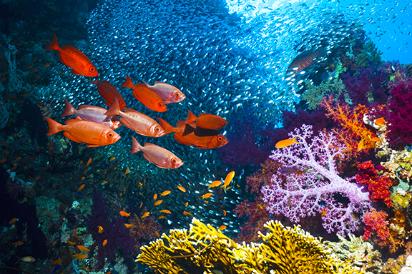
Figure 1. [Include all figures in their own section, following references (and footnotes and tables, if applicable). Include a numbered caption for each figure. Use the Table/Figure style for easy spacing between figure and caption.]
For more information about all elements of APA formatting, please consult the APA Style Manual, 6th Edition.

